## 

## User Guide

Crescent Steel and Allied Products Ltd. Reception System

#### [Version 0.0.1]

#### 

### 

### Authors:

Izaan Sohail

intern.it-izaan@crescent.com.pk

**Contents**

0

User Guide 0

Authors: 0

Getting Started 1

Introduction 1

Technology Used 1

Client Side: 1

Server Side: 1

Database Used: 1

Deployment / Backup and Restore Procedure: 2

Basic Flow: 2

Front End: 2

Back End: 2

Database: 2

Maintaining a User Screen / Procedure: 3

Hardware Requirement: 3

Software Requirement: 3

Screens 4

Login Screen: 4

Home Screen 5

Data Entry Screen 6

Check-Out Screen 7

Search Screen 8

PDF Display Screen 9

# Getting Started

## Introduction

The aim of the software is to digitalize the reception system and to maintain a database for whenever an outsider wants to enter the office for any purpose. This will enable the firm to later query that on a particular date how many outsiders came or how many times a certain outsider came to the firm.

# Technology Used

## Client Side:

1. React
2. Language: JavaScript
3. Packages used: Various npm packages

## Server Side:

1. Flash
2. Language: Python
3. API Built on: Flask

## Database Used:

1. MongoDB

# Deployment / Backup and Restore Procedure:

## Basic Flow:

* Install Git.
* Make GitHub Account.
* Download NodeJs from this link <https://nodejs.org/en/download/>
* Download pm2 using command line using this command “npm install pm2 -j”
* Install python version 3.9 from this link <https://www.python.org/downloads/>
* Make a Folder of work folder and open command line inside the folder.
* Run on command line “git clone <https://github.com/izaansohail/CSAPL_Reception.git>”
* Go inside the folder made.

## Front End:

* Go inside the Frontend folder and then inside react-project named folder.
* Run command ”npm install”
* Then run “npm run build”

## Back End:

* Go inside the Backend folder and then inside Backend_CSAPL named folder.
* Run on command line “pip install –r requirement.txt”

## Database:

* Install mongodb from this link <https://www.mongodb.com/try/download/enterprise>
* Make sure to tick the install mongodb compass button while installation process.
* Once compass is installed paste this string “” in the box displayed on screen and press connect button.
* Then press the Database being used which is “Reception_Name”
* Enter the collection named “Visitors”.
* From here you can view, edit, query, delete or add any data directly to the database.

# Maintaining a User Screen / Procedure:

# Hardware Requirement:

* Minimum core i3 processor
* Minimum 4gb ram
* Minimum 250gb hard drive
* Must have a camera attached with the system for image.
* Constant speed Wi-Fi must be available for database access.

# Software Requirement:

* Must have a browser downloaded i.e. chrome, edge.
* Must have windows 10 downloaded.

# Screens

## Login Screen:

* The Login Screen has a basic functionality.
* It will prompt a user for Username and Password.
* Session is attached to it to restrict unauthorized access.
* Both Username and Password are hard coded.

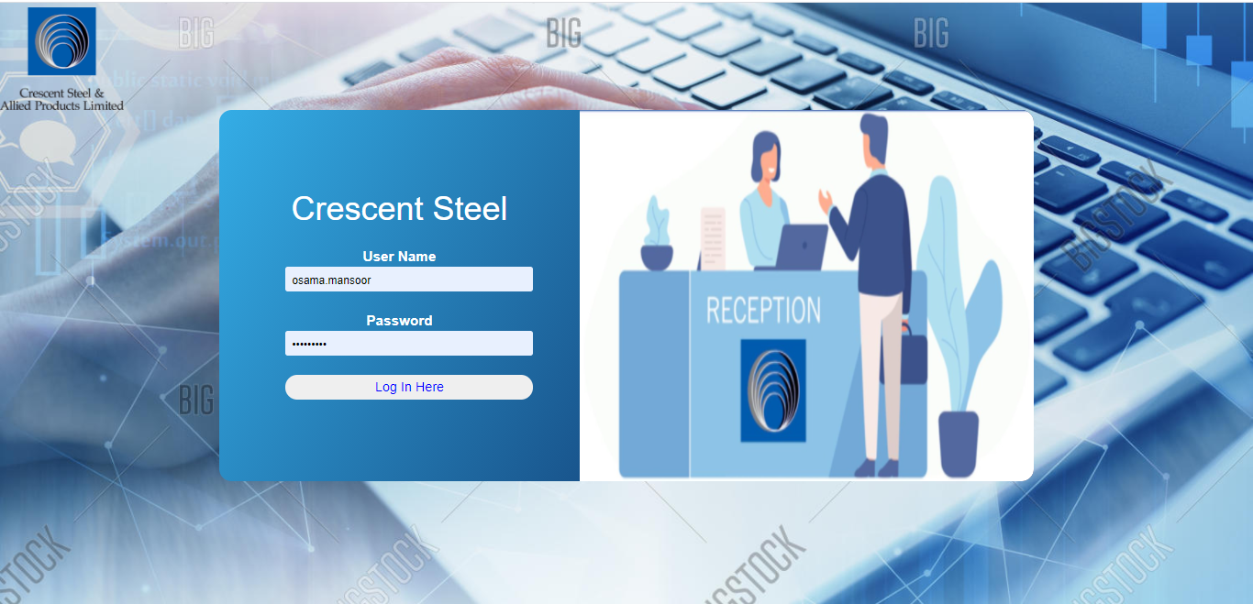

## Home Screen

* The Home screen has a navigation bar at the top with a Home button, Entry Button, Exit Button, Search Button and Log out Button
* The Entry Button directs us to the form for data entry.
* The Exit Button directs us to the checkout screen.
* The Search Button directs us to the data search screen.
* The Log Out Button takes us back to Login Page
* The Home Screen constantly keeps track of total visitors for the day, those among them who have checked out and those who are still in the building,
* The Home Screen also shows the total number of defaulters to date.

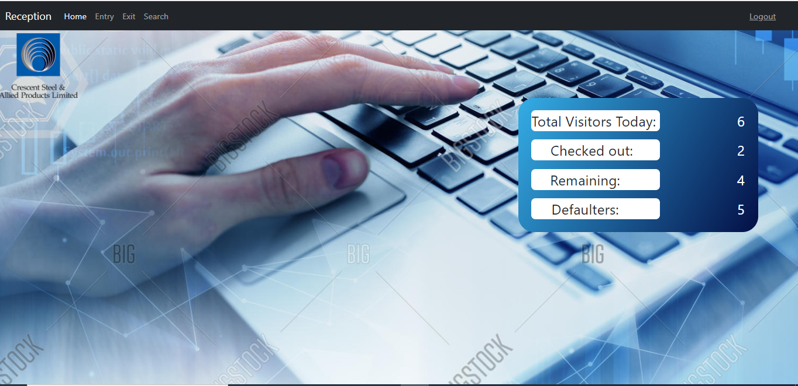

## Data Entry Screen

* This screen will be used to enter Visitor Data.
* In the name field user name will be typed.
* In the cnic field, user cnic will be entered which will be masked to the correct cnic format.
* In the person count, we can enter the number of visitors if they have all entered as a group.
* In the Name of Organization, enter the organization form where the visitor belong.
* In the Contact Number field, enter the contact number of the visitor.
* The Check-In Date and time will be extracted and recorded from pc and cannot be edited.
* The Check-Out Date and time will be disabled here on data entry screen.
* In Contact Person field, enter the name of the person to visit.
* In the Purpose of Visit field, enter the purpose of visit.
* Click on the cam image to take a picture of the visitor.
* Press submit Button to record data into the database user will be directed to Home Screen and an alert will be generated to show data successfully inserted.

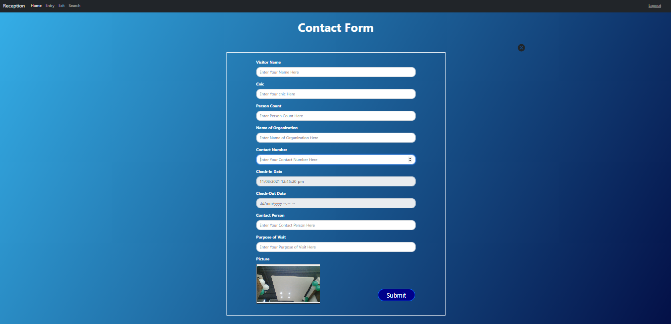

## Check-Out Screen

* This screen will display all the visitors who visited today and have not checkout yet.
* By clicking on the image icon you can see the image of the person
* By clicking on checkout button you can record the persons checkout time
* As soon as the person is logged out his record will be removed of this list.

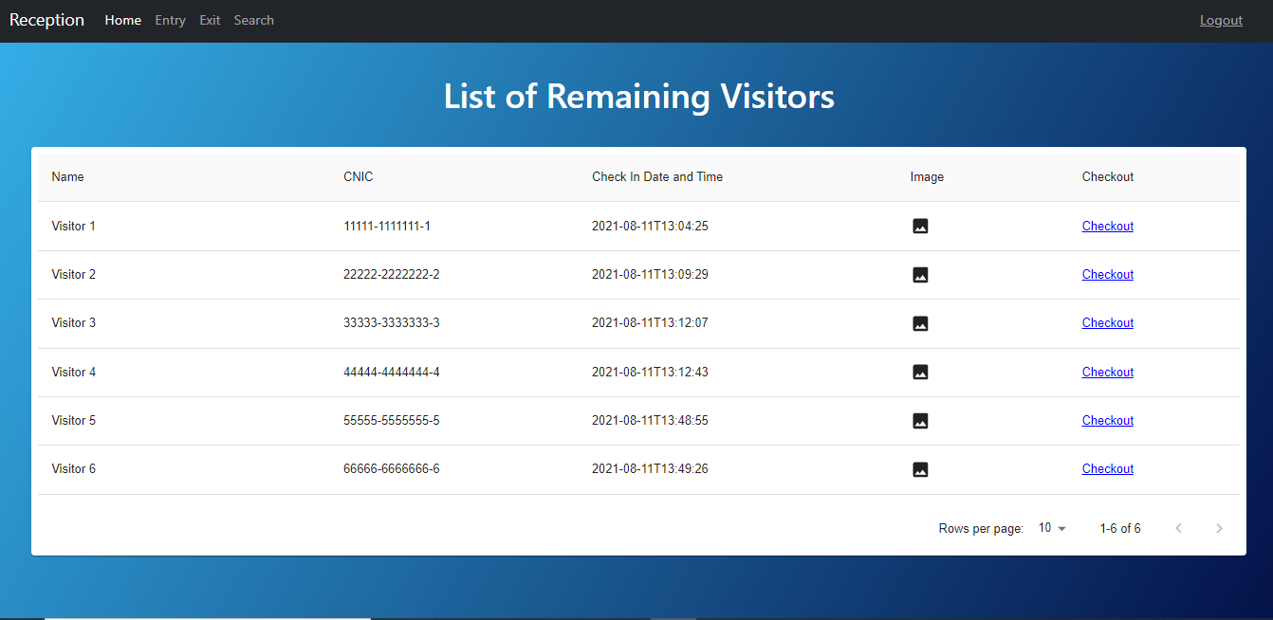

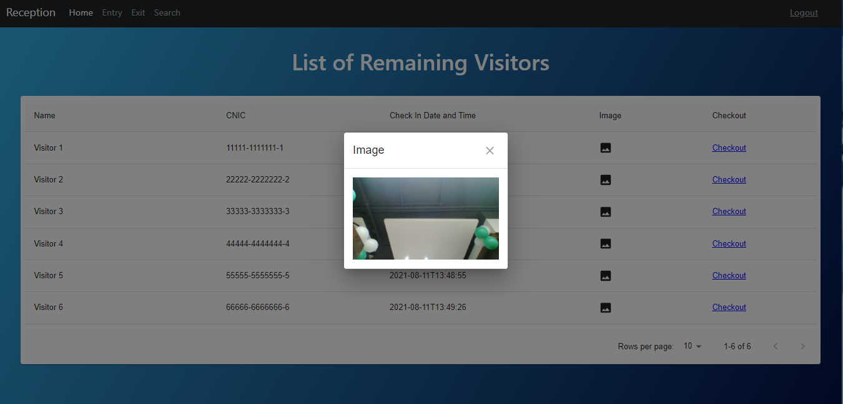

## Search Screen

* On this Screen multiple conditions and queries can be generated to fetch data.
* If empty query is sent all the data is returned.
* As soon as submit button is pressed data is fetched on below on the screen.
* Below the data table is a generate pdf button pressing which takes you to the pdf screen.

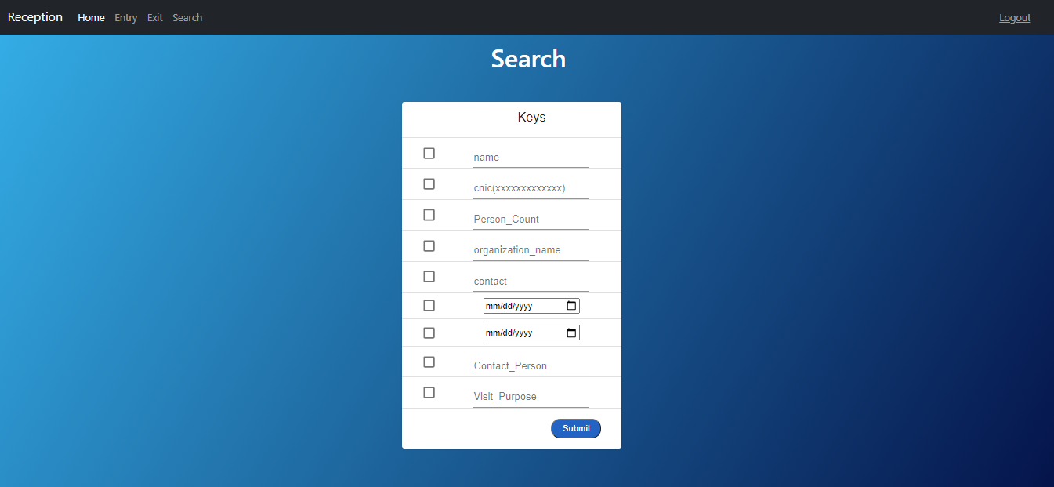

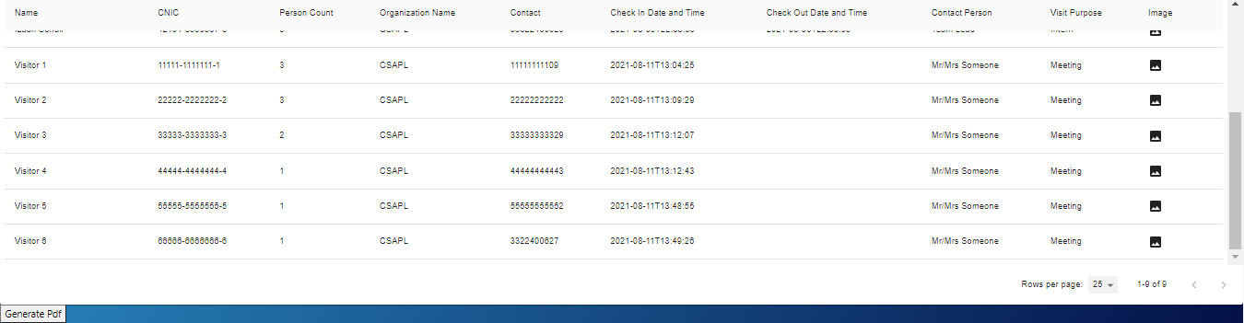

## PDF Display Screen

* The results obtained by the query are displayed here in a pdf form.
* All the functionalities that can be performed to the pdf can be performed to this pdf too.

